**Year 12 Physics**

**Semester 2 Examination 2017**

**Addendum**

**Student name:**

The following **TWO** questions are to be substituted in the examination.

***Please do your working on this page and ensure it is submitted with your answer booklet.***

**Section 1.**

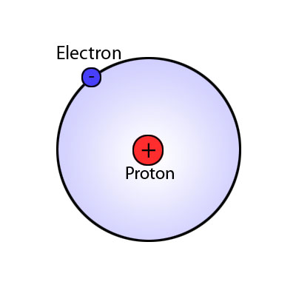

1. The distance between the proton and the electron in the ground state of the hydrogen atom is defined as the Bohr radius. Given that the Bohr radius can be measured as r = 5.29 x 10-11 metres, what is the speed of the electron as it orbits in the atom? **[5 marks]**

4. A proton has been accelerated to 95.0 % of the speed of light in the Large Hadron Collider (LHC). Calculate its relativistic energy. **[3 marks]**